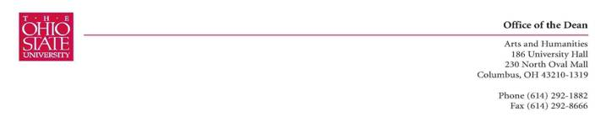
Rebecca Harvey
Chair, Arts and Sciences CCI

Dear Rebecca,

The Department of Women’s Studies would like to allow more courses on the major, they have sent a list of courses they would like to have added “Approved Related Courses” in addition to the currently approved Women’s Studies approved courses.

I am hopeful that this can be approved as an informational item at the ASC curriculum meeting on October 2nd. If you have questions about the proposal, please feel free to contact me at williams.1415@osu.edu, or 292-1882.

With my best,


Valarie Williams
Associate Dean, Arts and Humanities

